Welcome to
7th Grade Social Studies

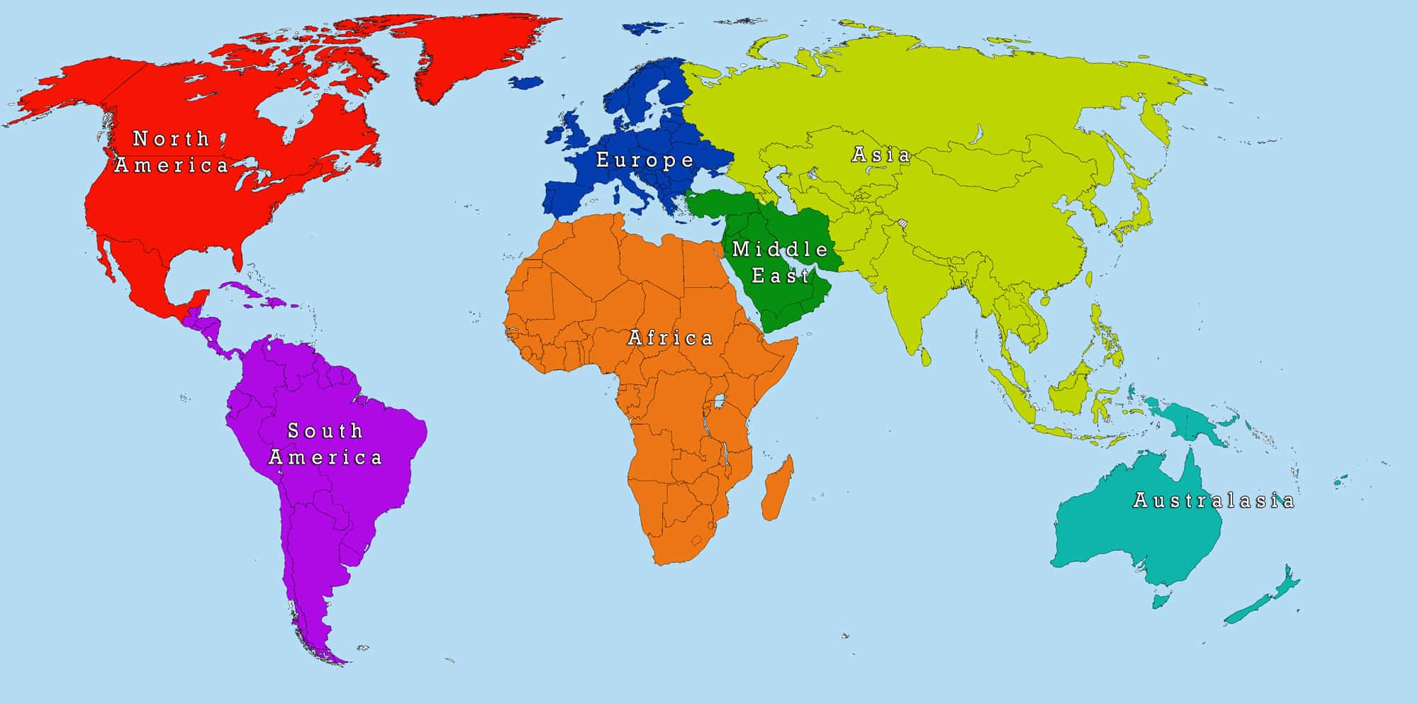

Dear Seventh Grade Students and Families,

Parents and students, welcome to Mr. Norris’ Seventh Grade Social Studies class. It is a pleasure to make your acquaintance, and I’m looking forward to this upcoming adventure that will be the 2019-20 school year. Seventh grade is vital to student development, and seventh grade social studies is particularly important.

My philosophy is to challenge my students to think critically about how the events in the time periods we cover resonate in the modern world. I encourage students to examine how the past plays a role in shaping the present, as well as sets the stage for the future.

This year, we will be learning about many different places around the world including Africa, Rome, China, Japan, and the Early Americas. Students will be able to showcase their understanding of the content through reading and writing exercises, projects, and field trips.

In order to be successful in Social Studies this year, it is essential that you enter the classroom each day with the proper materials, completed homework, and most importantly, a positive attitude. In order to do this, you must plan ahead and stay organized. 100% participation is expected 100% of the time. Participation is part of you grade.

I look forward to a wonderful year with you!

Mr. Norris, 7th Grade Language Arts

If there are ever any questions you can always contact me at (310) 412-2286 or through email mnorris@centurycharter.org. Remember to check PowerSchool, where you can see grades and any assignments that may be missing
Student Expectations

Students should Be Prepared

Students will Embody compassion

Students will be Accountable for their actions

Students will Respect self, other and school

Seventh grade is filled with many collaborative opportunities. You will work with a variety of students in various group settings. As a member of the class, you need to be respectful of your classmates, their views, and their unique qualities. You DO NOT have to agree with your classmates on everything, but I DO expect you to respect their opinions. In addition, you need to be respectful of your classroom.
Grading | BEGINNING OF CLASS PROCEDURE: | Materials
- Assessment 40%  - Activities 30%  - Homework 20%  - Participation 10% | - Line up outside and wait quietly to be let in  - Shake hands and greet Mr. Norris  - Write down the homework for the day  - Take homework out and ready to be checked  - Begin your DO NOW when you walk in  - Wait quietly for timer to go off  - Take out composition notebook | Two  - Two composition books  - Markers, crayons or color pencils  - Scissors  - Glue sticks  - Index cards  - Black and blue pens  - Three red pens  - Highlighters
BEHAVIOR:

In order to achieve success, it is important that we stay on task, this means that everyone is responsible for staying on task and focused.

Consequences for not following the classroom rules are:
- Tier 1:
  - A verbal warning
  - A Tele-parent
  - Silent Lunch and Tele-parent
- Tier 2:
  - Automatic Silent Lunch and tele-parent
  - Silent Lunch, loss of chair, loss of 5 participation points and tele-parent
- Tier 3:
  - Automatic referral
ABSENCES

If you are absent from school, it is your responsibility to check for missed assignments. If you know you are going to be absent, please ask me of upcoming assignments.
HOMEWORK
Homework is due at the beginning of class. Homework is extra practice at home and helps you do well in class, it is to be written down daily, if there is no homework write no homework in your agenda under the correct subject.

Homework grading:

Check = full credit- 10 points
Check minus = partial credit- 5 points (@ least 80% of the work is complete)
x = No credit- 0 pts.

It is essential that you put time and effort into each assignment you are given. If you hand in a paper or assignment that is lacking effort or neatness, you will be expected to resubmit the assignment or entry.

I have read the entire syllabus and understand the contents within. Please sign this sheet and return it by September 5th, 2019 to verify that the course materials are accepted, and expectations are understood. Thank you.
Student’s Name: ______________________________________________
Parent/Guardian Signature: ____________________________________
Parent/Guardian Printed name: ________________________________
Parent/Guardian Preferred Phone: ______________________________
Parent/Guardian EMAIL: ________________________________________

How does your child learn best?

What are your child’s strengths?

What are your child’s weaknesses?

Is there any specific information you would like to share about your child (glasses, hearing aids, etc.)?

